|  |
| --- |
| King’s College London |
| Cell Tracking Profiler |
| Manual for Installation and Use |

Contents

1 Installation (Windows) 2

1.1.1 Installing ICY 2

1.1.2 To install Cell Tracking Profiler on your computer: 2

2 Installation (Mac OS) 2

2.1.1 Installing Icy 2

2.1.2 To install cell tracking profiler on your computer 2

3 Running Cell Tracking Profiler: 2

3.1 Determining segmentation parameters 2

3.2 Running CTP 3

3.3 Track Manager 4

3.4 Data Milkshake 4

3.5 (Optional) Reformatting data 5

3.6 (Optional) Plotting in R 5

4 Appendix 5

4.1 CTP Troubleshooting 5

4.2 Tips for Track Manager 6

4.3 Sample R code 7

# Installation (Windows)

### Installing ICY

1. Download Icy from http://icy.bioimageanalysis.org/download
2. Extract the **icy.zip** file to a **Documents\icy** folder.

### To install Cell Tracking Profiler on your computer:

1. Download the Windows 2016a MATLAB Compiler Runtime from <http://ssd.mathworks.com/supportfiles/downloads/R2016a/deployment_files/R2016a/installers/win64/MCR_R2016a_win64_installer.exe>
2. Open the **MCR_R2016a_win64_installer**. Accept all conditions and install to the default location.
3. Copy and paste the folder **PhagoSightExe** in the **Users** folder.
4. Copy and paste the folder **caroff** in the folder **plugins** in the **icy** folder generated during ICY installation.
5. Copy and paste the folder **protocols** in the folder **icy.**

# Installation (Mac OS)

### Installing Icy

1. Download Icy from <http://icy.bioimageanalysis.org/download>
2. Install Icy to the general (not user-specific) **Applications** folder.

### To install cell tracking profiler on your computer

1. Download the Mac OS 2014b MATLAB Complier Runtime from <http://ssd.mathworks.com/supportfiles/downloads/R2014b/deployment_files/R2014b/installers/maci64/MCR_R2014b_maci64_installer.zip>
2. Open the **MCR_R2014b_maci64_installer** folder and double-click on **InstallForMacOSX.app**. Accept all conditions and choose the **Users** folder as the installation location.
3. Copy and paste the folder **PhagoSightExe** in the **Users** folder.
4. Copy and paste the folder **caroff** in the folder **plugins** in the **icy** folder generated during ICY installation.
5. Copy and paste the folder **protocols** in the folder **icy.**

# Running Cell Tracking Profiler:

## Determining segmentation parameters

1. Launch **ICY**.
2. Open the dataset to analyse (drag the dataset from the file explorer onto the ICY panel).
3. 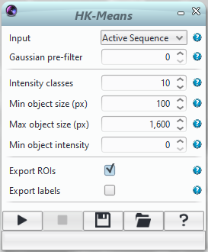Use the ICY search bar to open the **HK-Means** plugin.
4. Choose initial parameters for **Intensity classes**, **Min object size** and **Max object size**.
5. Launch the process by clicking on the **Run** (play symbol) button, and adjust the parameters until the segmentation fits the data optimally.
6. If there is more than one channel in the image to analyse, segmentation parameters should be determined for each channel separately.

## Running CTP

1. Use the **ICY** search bar to open the **Protocols** plugin.
2. In the **Protocols** window, select **Load**, and choose the *CellTrackingProfiler2.0_stef.protocol* file saved in the icy/protocols folder.
3. In the first block (**Folder**), click on **Choose folder name…** and select the folder where the dataset to analyse, is saved (each dataset should be in its own folder).
4. In the next block (**File**), click on **Choose file name…** and select the dataset for analysis.
5. Check that the value of **Frame** in each **My hierarchical K Means** is **-1**. Then for each channel copy the parameters chosen before for each channel.
6. If your image has more than one channel, the segmentation parameters for each My hierarchical K Means block must be entered.
7. Click on **Run** button. The process is running!
8. If you are running CTP on less than three channels then you will get an error message “*While running block “Extract Channel”: Parameter “channel”: Channel index must be between 0 and 0 / 1*”. Wait until the Icy output window shows “Lecture ok => _mat_Or” and then click continue. Clicking continue too early may abort the tracking process.
9. A new file called *Channel0_ROI+Label.xls* will be generated.
10. The program has finished when the message “*phagosight : File .xml generated*” appears in output terminal in ICY. A second file called *Channel0_tracks.xml* has also been generated.

## Track Manager

1. **Track Manager** is an ICY plugin that can be used to view and correct the tracks generated by Keyhole Tracker.
2. 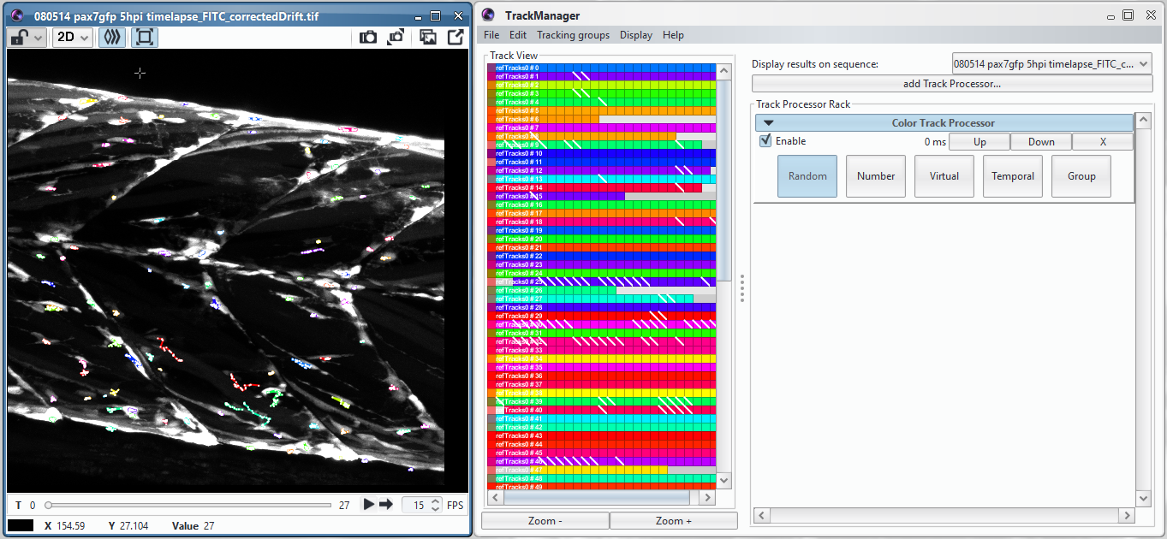Open the **Track Manager** plugin and the image if not already open.
3. Use **File -> Load** on Track Manager to select the *Channel0_tracks.xml* file generated by Keyhole Tracker.
4. Choose the image as the sequence with **display results on sequence**.
5. Adjust tracks as required (see Appendix for hints and tips on using Track Manager).
6. Save the corrected track file.

## Data Milkshake

1. Now the corrected tracks and segmented cell data can be combined.
2. 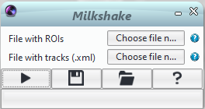Use the ICY search bar to find and open the **Milkshake** plugin.
3. Select the *Channel0_ROI+Labels.xls* file at **File with ROIs**.
4. Select the corrected track .xml file at **File with tracks**.
5. Run by pressing the play button.
6. A file called *Channel0_TracksMeasurements.xls* is generated. This contains a summary sheet and then the information for every cell is kept on a separate page.
7. Additionally, a folder of .csv files is also generated, with each .csv file being a single sheet of *Channel0_TracksMeasurements.xls.* This is useful for further formatting, especially in non-Windows OS.

## (Optional) Reformatting data

1. A MATLAB executable has been generated that processes the data for plotting in R using ggplot2.
2. Run the executable by clicking on **CTP2R.exe** (Windows) or **CTP2R.app** (Mac) in the relevant folder. Screenshots shown below are taken from a Windows computer but are relevant for Mac OS too.
3. After a short load time, the program will ask first to navigate to the relevant image file (the original dataset CTP was run on) and then to the TracksMeasurements folder of csv files.

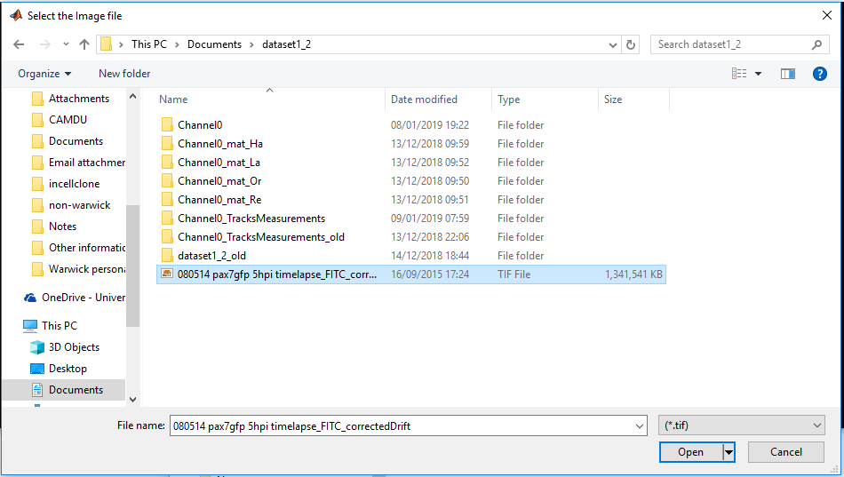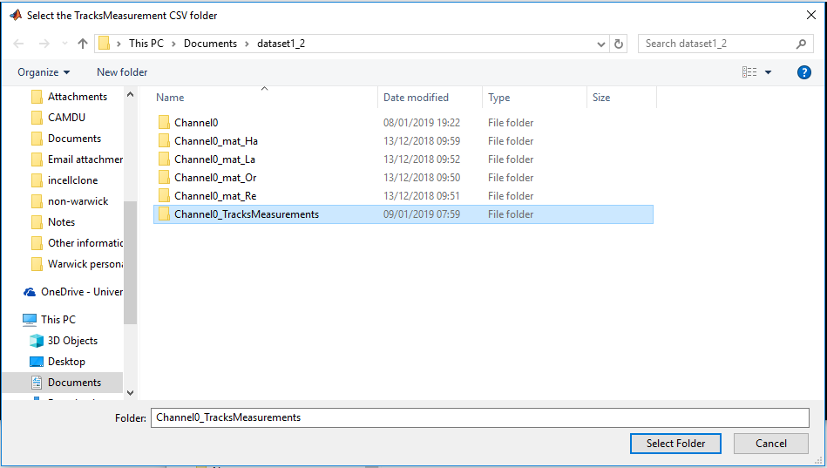

1. Input the relevant imaging parameters when prompted.

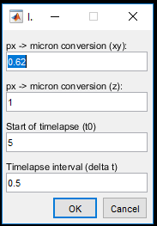

1. Input the number of desired ROIs when prompted (from 0-2 allowable).

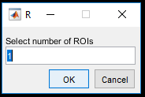

1. If an ROI number or 1 or 2 has been entered, the program will then display a maximum intensity projection of the image stack, overlaid with track data for freehand selection of an ROI.

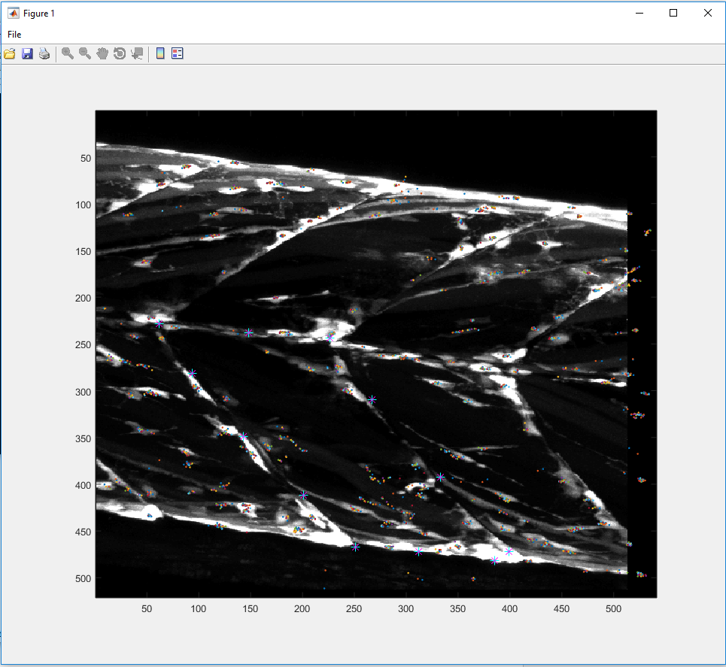

1. Click around the perimeter of the desired ROI, once an ROI is drawn, a double-click or return key will either continue the program or allow selection of another ROI if 2 ROIs were requested.
2. The program will then display cells within the ROIs in red and/or green and the cells outside the ROIs in blue. The blue cells will still be included in the output files as ROI label 0. The user is prompted to confirm if the ROIs are correct, selecting “*Yes*” will continue the program, selecting “*No*” will open up the ROI selection image again.

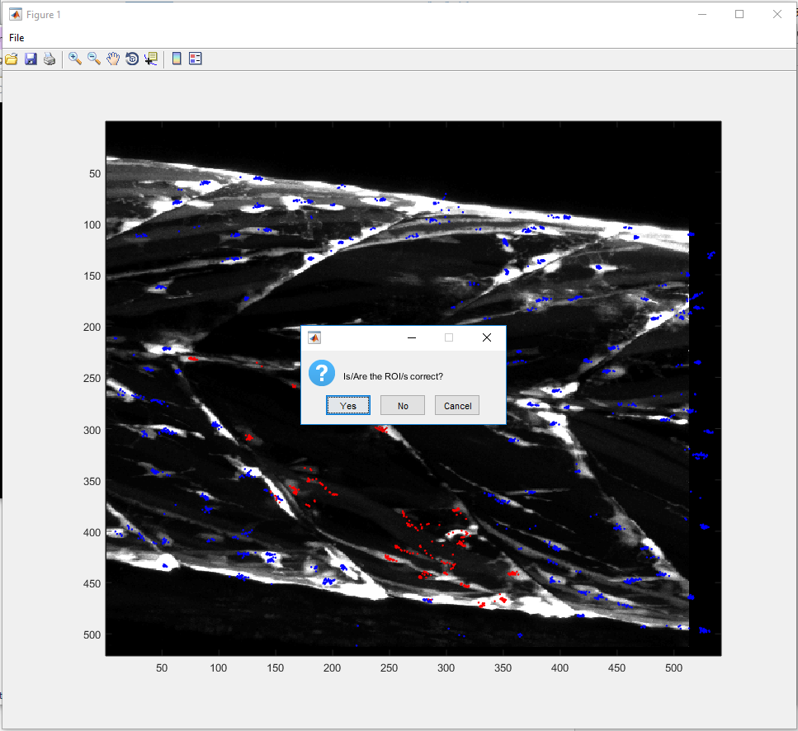

1. The program will then create two files called *<filename>_ggplot.xls* and *<filename>_ggplot_mean.xls* which can be used in Section 3.6 for generating comparative plots of your CTP data.

## (Optional) Plotting in R

1. Install and open **RStudio**.
2. Import the data using **File -> Import Dataset -> From Excel**.
3. See the appendix for sample R code.

# Appendix

## CTP Troubleshooting

1. If you are running the CTP protocol on less than three channels then you will get an error message “*While running block “Extract Channel”: Parameter “channel”: Channel index must be between 0 and 0 / 1*”. Wait until the Icy output window shows “Lecture ok => _mat_Or” and then click continue. Clicking continue too early may abort the tracking process.
2. While running the CTP protocol, you will see the warning “Label not found for xxxx (ROI line)” printed in the Icy output, this occurs when CTP cannot match a label to an ROI and is expected for a few ROIs within a dataset.
3. If you are running the CTP protocol on a Mac, you may see the error “*No Info.plist file in application bundle or no NSPrincipalClass”* in the Icy output. In older Mac OS (10.11 and below) you can fix this by running the osx-appfix file in the Icy folder, this will launch Icy and the launched version should not show this error. If you are running newer Mac OS (10.13 and above) then you will need to run the following command lines in the Terminal.

cd /Applications/icy/

xattr -dr icy.app/

java -jar updater.jar

These commands will need to be rerun after each Java update.

1. Occasionally, the CTP protocol will not output every desired parameter, this can affect downstream processing. This problem can be confirmed by opening up the *ChannelX_ROI+Labels.xls* file. If the following parameters shown as ticked in the figure below then you may not be able to run Milkshake or CTP2R correctly. This can be rectified by clicking and unclicking the missing parameters, resaving the protocol file and rerunning.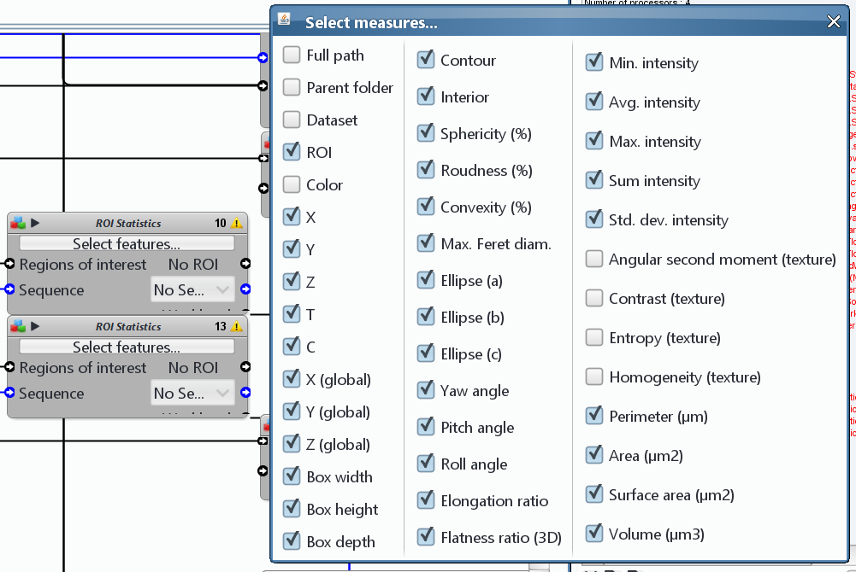
2. While running Milkshake, you may see a message “*ERROR: format of tracks is unadapted*”, this is a warning rather than an error and should not affect the operation of Milkshake.

## Tips for Track Manager

* To connect two tracks, simply drag from one block on a track to another. If you are happy with the connection, select Fuse All track-segments to fuse the connection into one track.
* To split incorrect connections, connect a track at the point of the incorrect connection. You can then use “delete links on selected tracks” to then delete the undesired connection.
* **Save frequently**, it’s very easy to accidentally delete a track and there is no undo.
* It is usually sufficient to plot the tracks on a maximum intensity projection (use the plugin Intensity Projection on the image) for correction, this makes things easier to view. It is only when two cells are on top of each other that the full 4D view is required.
* The Track Processors **Time Clip** and **Z Clip** are indispensable when tracks are dense and overlapping. You can use these to display only certain parts of tracks, selecting by time and Z position.
* Colour the tracks by number (effectively time) using **Color Track Processor**, this allow you to see more readily tracks that might need connecting as earlier tracks are coloured green, through to pink and red for later tracks.
* One of the downsides to Track Manager is that you can only connect tracks that are both visible on the Track View. Zooming out on Track View allows you to see more tracks on your screen.

## Sample R code

#This will plot the final directionality value using the “_mean.xlsx” spreadsheet generated by CTP2R as a separate violin plot for each ROI with mean and standard deviation error bars and significance values

#Load required libraries

library(ggplot2) #plotting library

library(readxl) #excel reader

library(ggpubr) #significance values

#Read in Excel spreadsheet

dat <- read_excel('insert path to spreadsheet here')

#defines a function to plot the mean and standard deviation

data_summary <- function(x) {

m <- mean(x)

ymin <- m-sd(x)

ymax <- m+sd(x)

return(c(y=m,ymin=ymin,ymax=ymax))

}

#defines the ROIs labels and colours for plotting

lab1 = c("control", "ROCKout", "y-compound")

val1 = c("black", "red", "blue")

lab2 = c("control", "control", "blebbistatin", "blebbistatin")

my_comparisons <- list(c("0","1"), c("0,2"), c("0,3"), c("1","2"), c("1","3"))

ggplot(data = dat, aes(x = roi, y = directionality)) + #set the data and x and y aesthetics

geom_violin(aes(color = roi)) + #plot a violin plot coloured by ROI

theme_bw() + #simple plotting theme

ylab('Directionality curve') + xlab('') + #set the x and y axis labels

stat_summary(fun.data=data_summary, aes(color = condition)) + #add the mean and standard deviation error bars

scale_x_discrete(limits = lab1, labels = lab2) + #label the x axis

scale_colour_manual(values = val1) + #colour the plots

stat_compare_means(comparisons = my_comparisons) #add significance values (if desired)